It’s one of the most imp question asked in interview for logistic regression

**If you have data which is not linearly seperable, then how do you apply logistic regression?**

The simple ans is using feature engineering, below figures shows this.

This example where data are in circular form which are concentric, and we generated new features as given below.

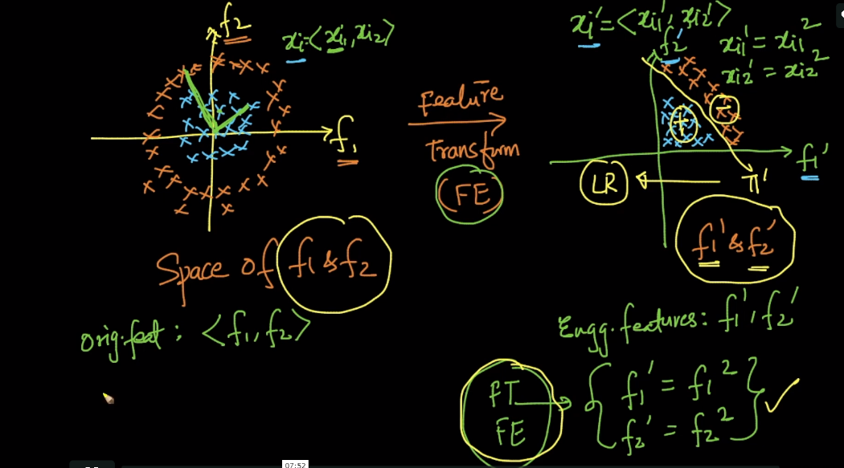

Now when new data point come to identify it’s class, we convert it’s feature according to new feature obtained by feature eng, and apply to model.

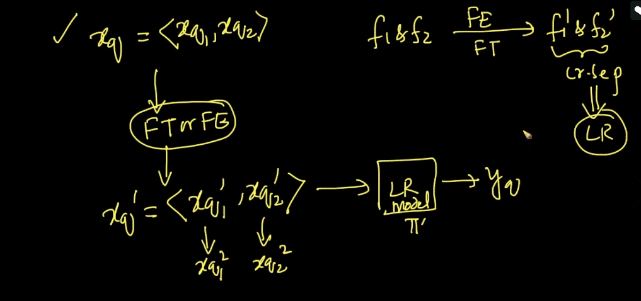



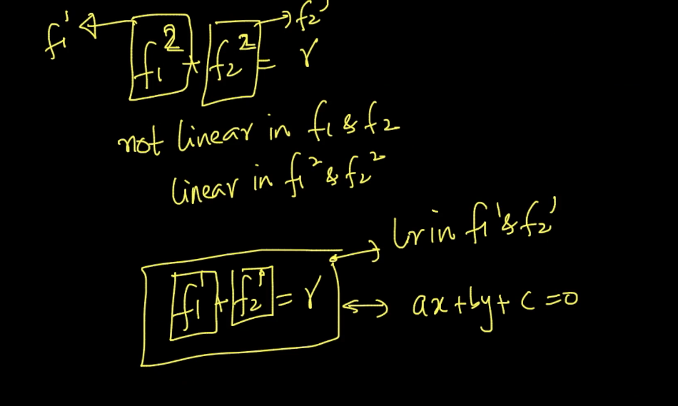

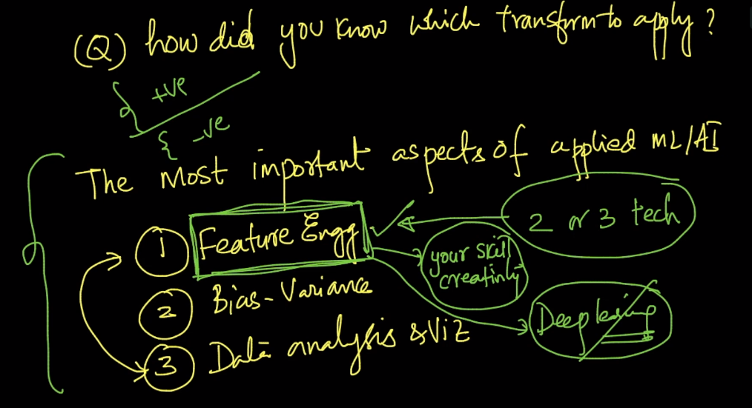

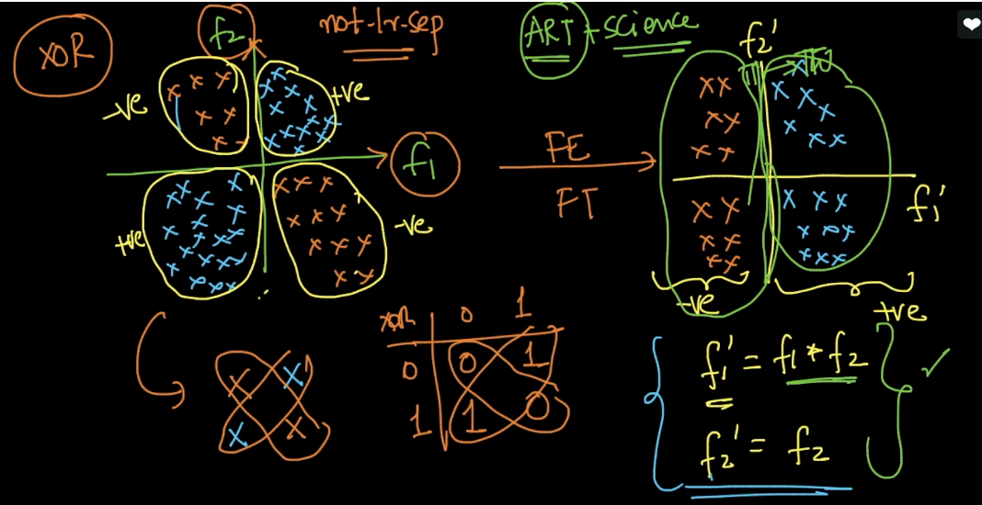

Below image shows data which is in alternate form, we can create new form of data using sin function which is positive and negatively alternatively, but check that width of wave is similar to width of data, otherwise modify sin function according to data.

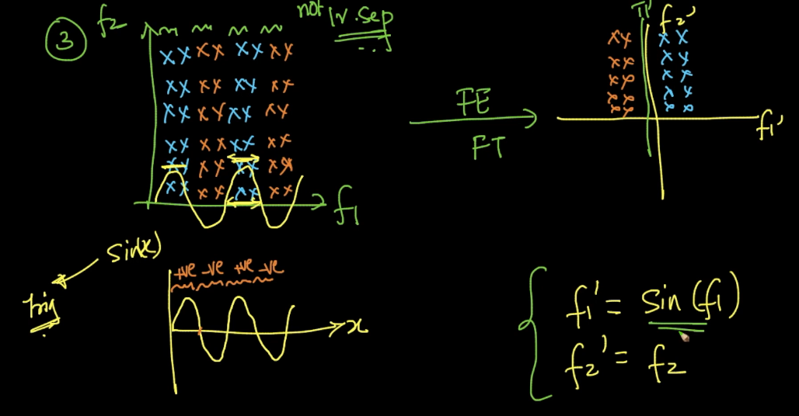

Typical function we used for feature eng, are given below.

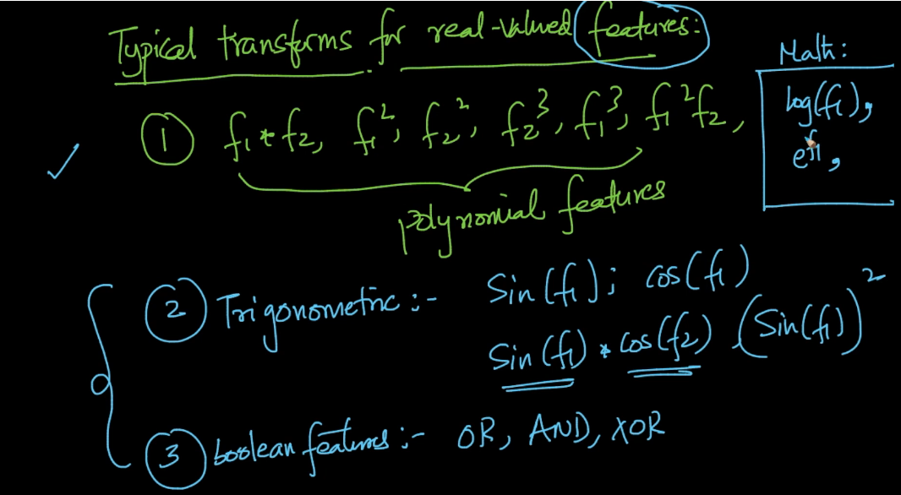

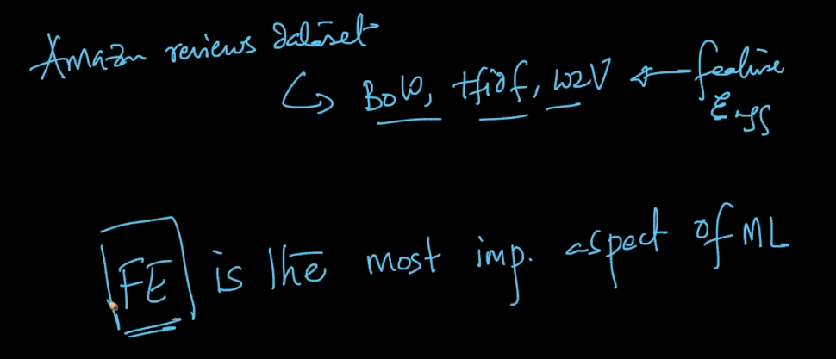

Comments:

